**AWS Developer Certification | AWS Certified Developer Associate (FIRST 6 HOURS)**

[AWS Developer Certification | AWS Certified Developer Associate (FIRST 6 HOURS) - YouTube](https://www.youtube.com/watch?v=WYPG6Sdx1os&t=2907s)

# AWS CLI

**Pre-requisite**

First login to IAM console and create a new user. Click user and create new “security credential” like given above. Also, grant relevant permissions like ec2, s3 full access etc.

Once done, configure this user In AWS CLI initially.

1. `aws configure`
2. Add above access key n secret and rest can be blank.
3. Run any aws command like aws s3 ls

**Common commands:**

* aws help
* aws help ec2
* aws help s3 ls - shows list of buckets
* aws s3 cp testfile_via_cli.txt <s3://sg02-training-bucket> - copy file to given bucket
* aws s3 ls <s3://sg02-training-bucket> - show all files in given bucket

**Other useful commands:**

* Cat .aws/config - check configurations
* Cat .aws/credentials - check cress

#### **EC2 command list**

Saranshs-MacBook-Pro:~ saranshbansal$ aws ec2 help

o restore-snapshot-from-recycle-bin

o restore-snapshot-tier

o revoke-client-vpn-ingress

o revoke-security-group-egress

o revoke-security-group-ingress

o run-instances

o run-scheduled-instances

o search-local-gateway-routes

o search-transit-gateway-multicast-groups

o search-transit-gateway-routes

o send-diagnostic-interrupt

o start-instances

o start-network-insights-access-scope-analysis

o start-network-insights-analysis

o start-vpc-endpoint-service-private-dns-verification

o stop-instances

o terminate-client-vpn-connections

o terminate-instances

o unassign-ipv6-addresses

o unassign-private-ip-addresses

o unassign-private-nat-gateway-address

o unmonitor-instances

o update-security-group-rule-descriptions-egress

o update-security-group-rule-descriptions-ingress

o wait

o withdraw-byoip-cidr

#### **S3 command list**

Saranshs-MacBook-Pro:~ saranshbansal$ aws s3 help

The command **aws** **s3** **cp** **/tmp/foo/** **s3://bucket/** **--recursive** **--exclude**

**"ba*"** will exclude **/tmp/foo/bar.txt** and **/tmp/foo/baz.jpg**:

/tmp/foo/ba* -> /tmp/foo/.git/config (does not match, should include)

/tmp/foo/ba* -> /tmp/foo/.git/description (does not match, should include)

/tmp/foo/ba* -> /tmp/foo/foo.txt (does not match, should include)

/tmp/foo/ba* -> /tmp/foo/bar.txt (matches, should exclude)

/tmp/foo/ba* -> /tmp/foo/baz.jpg (matches, should exclude)

Note that, by default, all files are included. This means that

providing **only** an **--include** filter will not change what files are

transferred. **--include** will only re-include files that have been

excluded from an **--exclude** filter. If you only want to upload files

with a particular extension, you need to first exclude all files, then

re-include the files with the particular extension. This command will

upload **only** files ending with **.jpg**:

aws s3 cp /tmp/foo/ s3://bucket/ --recursive --exclude "*" --include "*.jpg"

If you wanted to include both **.jpg** files as well as **.txt** files you can

run:

aws s3 cp /tmp/foo/ s3://bucket/ --recursive \

--exclude "*" --include "*.jpg" --include "*.txt"

**SYNOPSIS**

aws s3 <Command> [<Arg> ...]

**OPTIONS**

None

**AVAILABLE** **COMMANDS**

o cp

o ls

o mb

o mv

o presign

o rb

o rm

o sync

o website

# VPC, SGs, NACLs

# VPCs are like your own data centre in AWS cloud. It provides logical isolation for a group of components from other VPCs. By default, you can create 5 VPCs per region.

# VPC can span across multiple AZs. Each AZ has public and private subnets to isolate the inbound/outbound traffic.

# VPC consist of its own CIDR (Classless inter-domain routing) block. Each subnet has a block of IP addresses which is part of CIDR block.

# Each subnet consists of resources like EC2.

# VPC Router takes care of routing within and outside AZs. It is controlled by using Route table.

# Internet Gateway is attached to VPC to connect to outside internet.

# VPC Endpoints: To provide private connection to public AWS services

# Security groups: Instance level firewalls

# NACL: Subnet level firewall

# NAT Instance and Gateway: Provide Internet connection for your EC2 instances in private subnets

# Security group vs NACL

# Instance level firewall ||| Subnet level firewall

# Allow only rules ||| Both Allow and Deny rules available

# Stateful: any traffic allowed out will automatically be allowed in ||| Stateless: NACLs need separate outbound rules

# Setup VPC

1. Login to IAM account
2. Got to VPC service
3. Create new VPC by providing a custom range: 10.0.0.0/16
4. Edit VPC settings and select “Enable DNS hostnames”
5. Create public and private subnets by going to Subnet and assigning IP CIDR blocks (ex. 10.0.1.0/24 ,10.0.2.0/24…). Chose AZ as US-east-1a
6. Create a routing tables – private subnets and public subnets called MAIN-RT.
7. Go to routing tables individually and associate subnets to them.
8. Got to internet gateway > actions > attach your vpc
9. Got back to route table > chose main route table and go to “routes”.
10. Create new route and associate igw with destination as 0.0.0.0/0.
11. Create a NAT gateway and associate it with a PUBLIC subnet. Allocate an Elastic IP and create it.
12. Go to route table, select private RT, click add route, and associate a NAT gateway this time like in step 10.
13. Create a Security Group Public-Web and add inbound and outbound rules. Keep it all traffic open for now.

# Launch EC2 instance

# CLI: aws ec2 run-instances –image-id <value> --instance-type <value> --security-group-ids <value> --subnet-id <value> --key-name <value> --user-data file:// <value>

# Setup your VPC with all the components. You need to create ec2 instances for all the public/private subnets as below:

# Go to EC2 dashboard and launch new instance. Grab Amazon AMI Id:

# Instance type = t2.micro

# Go back to VPC dashboard -> Security groups. Chose Public-Web security group and copy the SG id:

# Go to Subnets and copy Public 1A subnet id:

# Key name is key-pair you use in EC2. Go back to EC2 console -> Key pairs and just copy name:

# User data is a file with bunch of script to show some details in a web page. Provide the path to that file:

# Go to AWS CLI and run the command. Your new instance will launch. Rename it to Public 1A. Do the same for other public and private subnets

# EC2 Storage

**EBS**

Storage service available to connect to EC2 over a network.

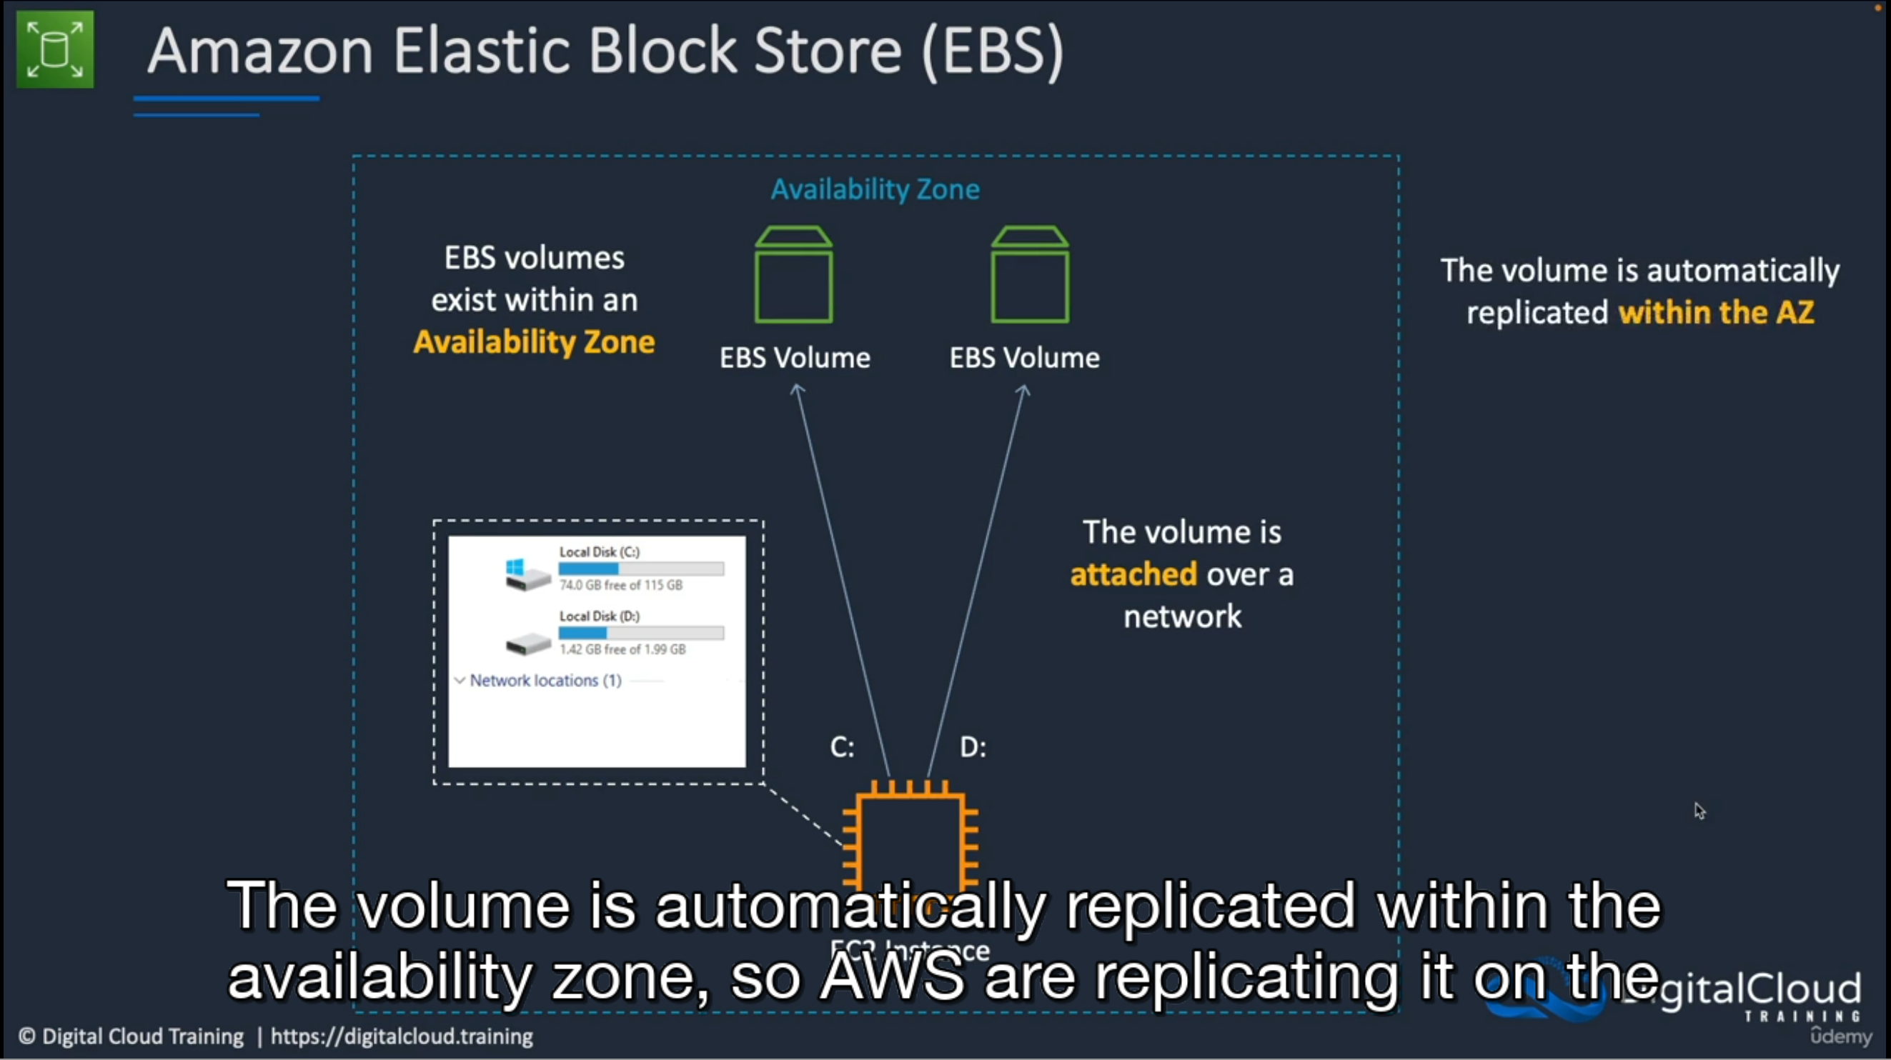

EBS Volumes are available inside AZ. They are automatically replicated within AZ.

**Types of EBS**

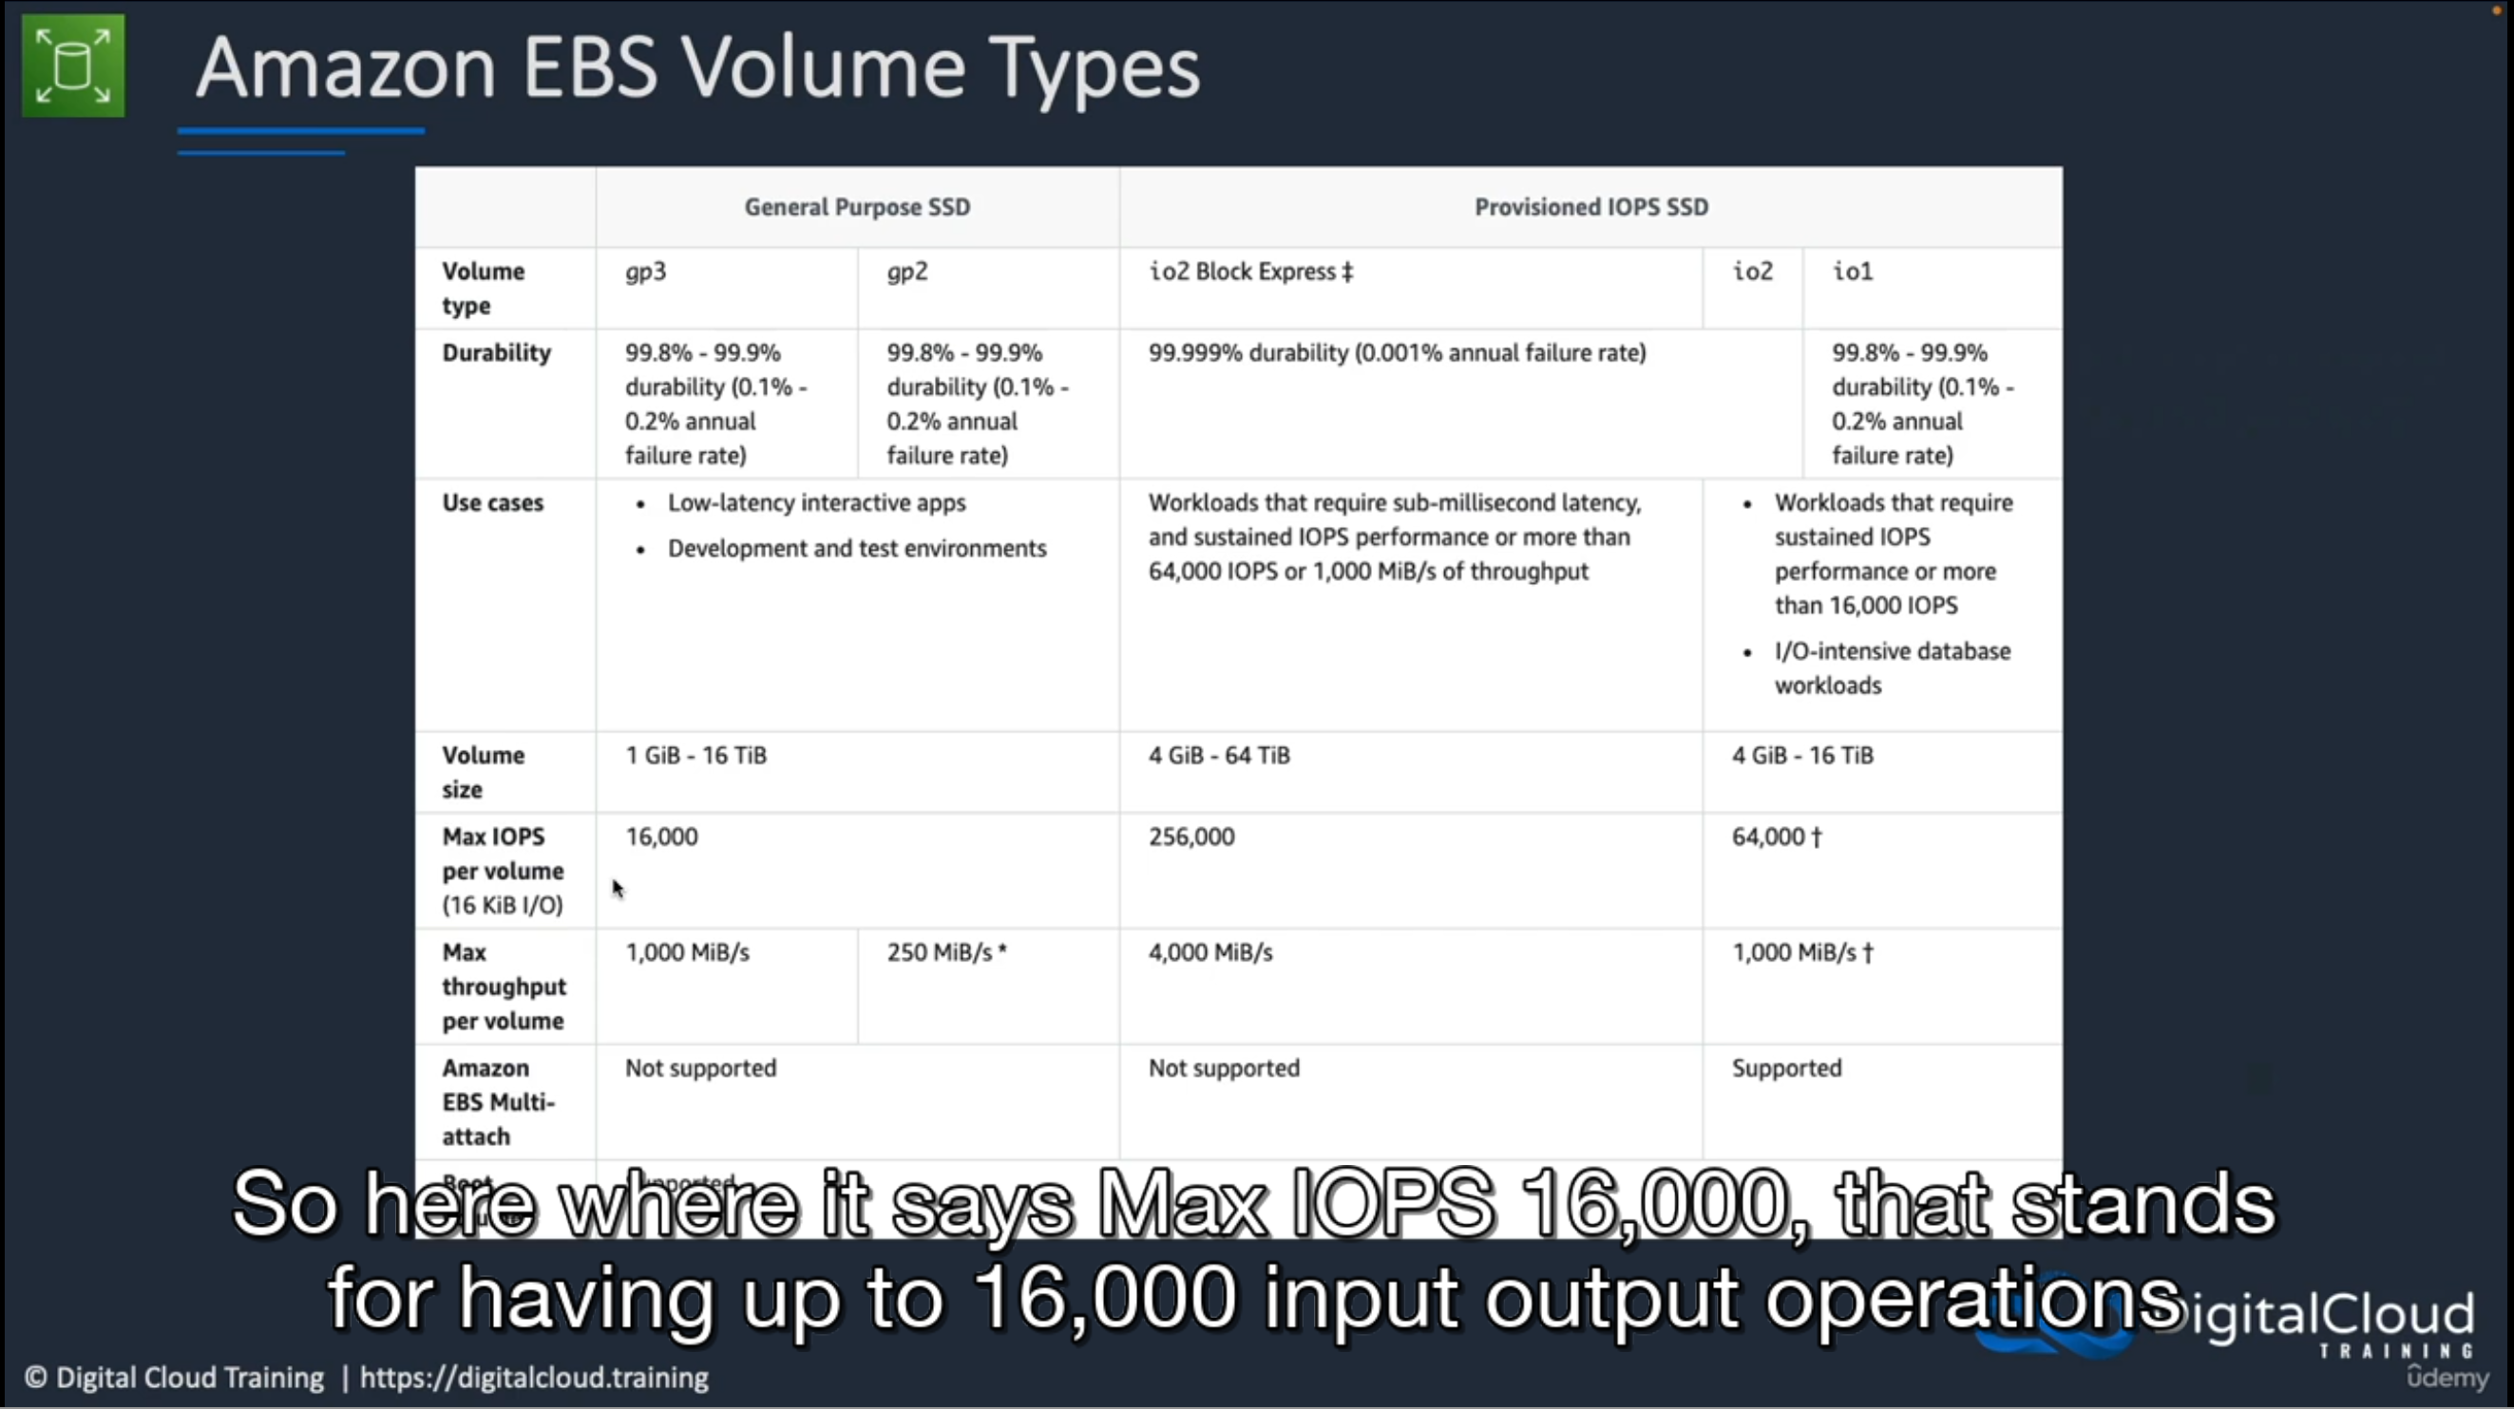

* Performance metrics: IOPS

**Instance store**

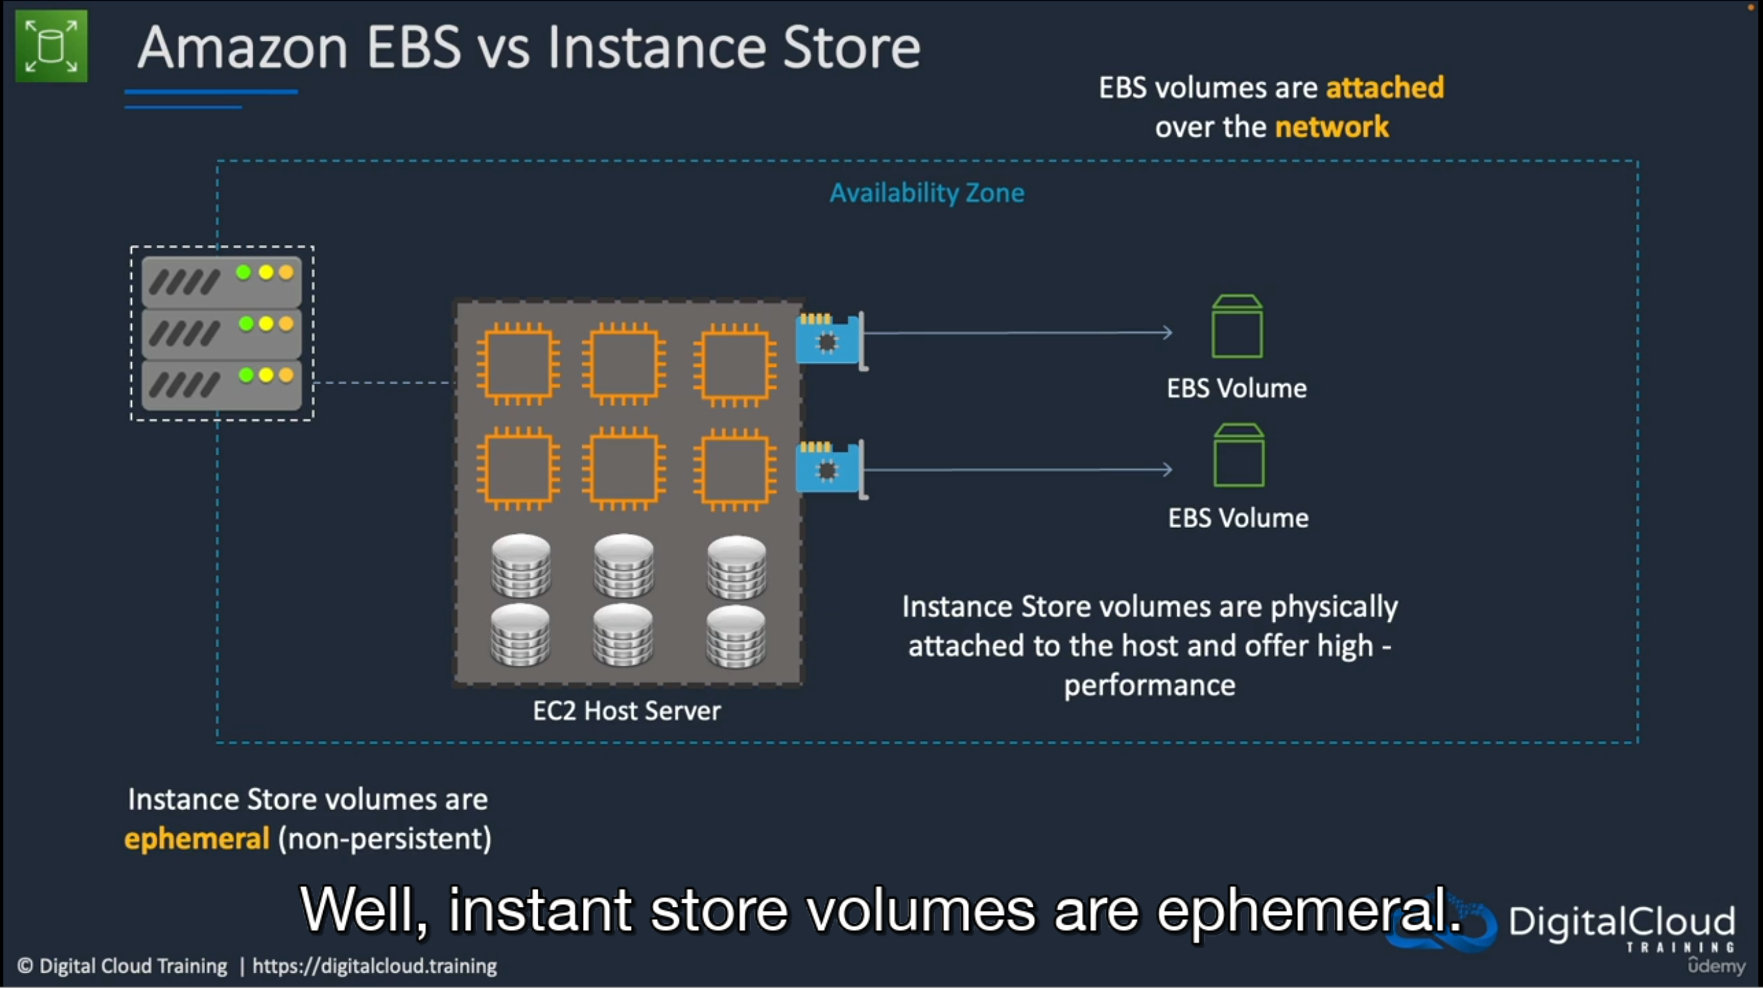

* Instance store is non-persistent and are physically attached to EC2 servers.
* They offer high performance and are used for storing data temporarily which doesn’t need replication.

**EBS Snapshot (for backup)**

# 

# Snapshots are created for EC2 Volumes. These are stored outside AZ in S3.

# Because they are outside AZ, they can be re-used in some other EBS volume in another AZ.

# They can also be used to create AMIs

**EFS (Elastic File System)**

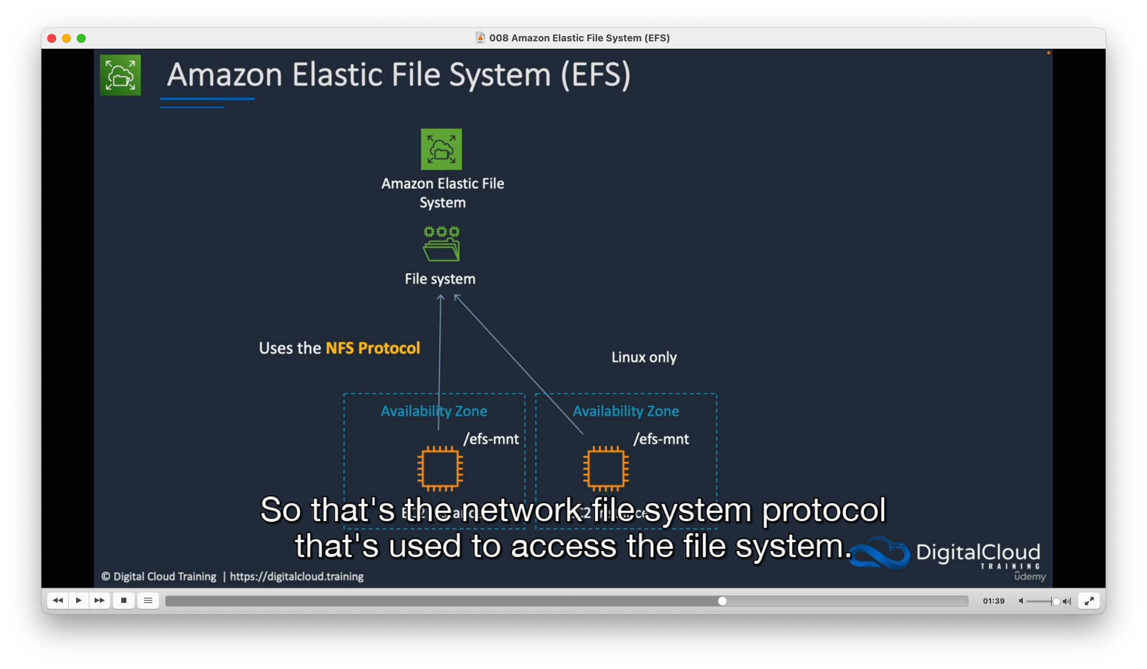

# EFS is file based storage service located outside of AZs (unlike EBS) and can be attached to multiple EC2 instances across AZs. It is a great way to attach a shared storage location between instances across AZs. Supports very large number of instances across many AZs unlike EBS which has certain constraints. EFS > EBS!

# Access to FS is via NFS (Network file system protocol) and is linux only that’s why we have mount points rather than drive letters.

# Can be connected to Corporate on-prem data centre.

# EC2 User data and Metadata

# User data: Allows you to run some code before running instances. Limited to 16kb

# 

# Metadata: Data about EC2 instance. By default located at http://<ip-address>/latest/meta-data/<commands>

# 

# How to launch an Auto-scaling Web App on EC2

# Open EC2 page

# Create a new launch template with following changes: - Name it MyEC2WebApp - Select AMI (Amazon linux) - Chose instance type (t2.micro) - Chose your keypair (create new if not already) - Under network setting, attached a subnet and security group (or create new)

# Under “Advance network” configs, enable “Auto-assign public IP”.

# Under “Advance details”, scroll at the very bottom to provide some user data which will be a web app using some external packages.

#!/bin/bash

yum update -y

yum install -y httpd

systemctl start httpd

systemctl enable- httpd

EC2AZ-$(curt -s http://169.254.169.254/latest/meta-data/placement/availability-zone)

echo "<center><hl>This Amazon EC2 instance is located in Availability Zone: AZID </h1></center> > /var/www/html/index. txt

sed "s/AZID/$EC2AZ/" /var/ww/html/index.txt > /var/www/html/index.html

# Launch instance.

# Click View template, open Auto-scaling group section. Create a new ASG group and name it ASG1.

# Choose your newly created launch template and click next.

# Choose Network settings: VPC and subnets. Only select all public subnets.

# Keep clicking next till you see summary. No need to change anything else apart from those.

# Make sure your Security Group does have http rule enabled. Select your ASG and check.

# If HTTP type rule is not there, edit SG and add it.

# Go back to “Instances” section and you should have a running instance which is your web app. Select and check ip address to access it.

# AWS CloudFormation

# 